Jovan Rodriguez
ENC1102 – Professor Proulx
29 October 2019
Research Paper
Communities of Practice in a Professional Environment
Introduction
When you are introduced to a new place, it may take you awhile to get accustomed to the way things are done in that new environment. You can find the framework of a community or communities in practice everyday day activities everywhere you look. Many people think that a community of practice has to be a group. However, when one of the authors of my sources, Wenger was interviewed, he was asked about a community of practice, he said that “a community of practice does not necessarily need to be a group”(143), because he sees a community of practice as a learning tool, a way to better others by making different groups with similar interests, all work together to learn about the same topic at the same time. They occur in social environments, in academic environments, and as well as in professional environments. However, each community of practice has its own requirements, its own minor details that qualify them as communities of practice. There are three main components, three main points that must be achieved in order to qualify it as a community. According to Shin, these three points are a domain, a specified community and a practice.
There are different types of communities of practice in play. Shin and Johns both touch on the categories and their generalized points. As said earlier, three major categories are academic, social and professional communities of practice. These are Johns thoughts and what she believes to be so, however Shin believes in almost the same ones, but just a slight difference. Shin says that the four major categories of a community of practice revolve around interests, goal-oriented, a learners’, and professional communities. These two are practically the same just with a few minor differences.
Being a new workplace has it values, but more often than not people struggle. Whether it be speaking to other employees about work, or simply just hanging out. Wardle uses an example of a young man named Alan. Alan is newly employed as a computer-specialists for the Humanities department. Being the new guy, on top of being the youngest guy in the department, Alan’s writing is not exactly the best, according to the other department members. Wardle speaks about writing in a new workplace, what to do, how to do it, and what to look for. Alan is a prime example for writing in a new place. He could never manage to write how in the manner his coworkers did and his coworkers would never write how he has written emails, letters, etc. Wardle explains this as each and every person wants to establish themselves everywhere, they go, they want to be able make it known that they are there. They do not want to get accustomed to how others do things in social communities. This in a way works with what Wenger says about social theory. Wenger describes social theory as neither a perspective nor a true or false statement. His ideas on social theory closely resemble how Wardle explains Alan’s situation. Because social theory has a specific purpose, it is to say that Wardle’s specific purpose for Alan, is to try and get accustomed to the ways of the people who were there before you.
Wenger and Fergusson both talk about learning more than anything. Fergusson focuses on work-based learning and how it will in turn be better for all of us. By being required to do the actual work, we are more likely to retain information faster. So, for example, if we were to used Fergusson’s ideas on work-based learning, to mix it with Wenger’s Social Theory, we should be able to identify certain aspects of both sides and understand what makes a community and what doesn’t. We should be able to identify the different kinds of communities and explain how they work. With Fergusson’s idea of work-based learning we have to apply what we learn on a daily basis and combine it with what we want to learn to yield the best result possible. This works hand in hand with Wenger’s plug and play ideas. Plug-and-play is supposed to make it easier for users and make them more disciplined. Using Plug-and-Play and work-based learning, we can incorporate the practice theory that is talked about by Moring. She describes the practice theory using the words of Wenger and Schatzkian with what they believe it to be, their commonalities and their differences. With the practice theory being a “constellation of activities” (Moring 8) practice is required to get the points right. Plug-and-play and work-based learning can be used in this scenario because it allows you to get and understanding of how practice theory works because you take what you already know and combine it with what you will be learning, allowing you to further understand the topic at hand.
With a combination of my primary and secondary sources I will be analyzing how the types of speech and text used in a Financial career environment allow someone to work and adapt to this specific community of practice. Throughout this paper, I will be focusing on the question raising aspect, which allows me to further go into detail about my community of practice. My secondary sources provide the necessary information for my framework that I will then back up my primary sources allowing them to the focus more on the research question.

Methods
To gather my primary research, I used three out of the four types of methods that were provided. For my first two sources, I used Reddit threads pertaining to the Finance career environment. The Reddit threads pertain to environment of a Finance career because while one article talks about the highs and lows, but mostly lows of working on Wall Street, the other thread talks about what it is like to be a Financial Analyst and the opinions of people in the position. I chose text collections, over surveys because it was more relevant and yielded better information than a survey would. I also chose to used double entry notes to record observations of a Youtube video that highlighted the day in the life a Senior Financial Analyst for Amazon, Adya. With this video, I was able to understand what it is like working for a big company like Amazon and was able to observe what my life would semi consist of if I were a Senior Financial Analyst. My final source that I used was an interview with Monica Quiceno, a Senior Feasibility Analyst for Marriott. She described what her average day is like, talked about her work relationships, how they have impacted her personal life and how she has been able to impact the lives of her coworkers.
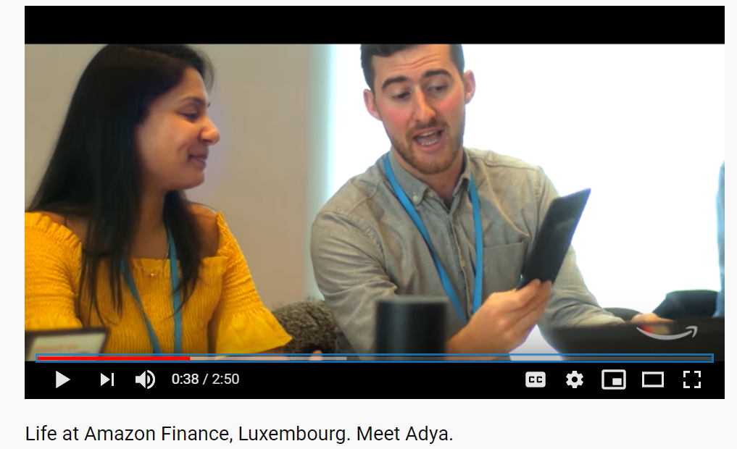
Fig.1 Adya talking with coworkers about technology that will drive the world.

Results
Text Collection: Why working in Finance is miserable?
In my first thread, I used one that spoke about the type of work environment they work in, how it affects them, and how they like it. The first response was fairly negative because threader u/ParadoxicalCabbage, talked about his experience while working on Wall Street and talking about he hated his time there. He would complain about not having any free time, no “normal life of a 20-year old” (u/Paradoxical Cabbage). Threader u/Paradoxical Cabbage enjoyed the money and financial independency he received from working on Wall Street, but did not enjoy feeling like a “cog in a machine that exists to make money”. This threader practically bashes working on Wall Street and complains about the entire process, but there are two other threaders in this thread that contradict what has been said. Threader Dhhgdghrdg speaks about how yes, the hours are longer than your average job, it does not mean that you are working all of the 90 hours. You have days off, times in which you can spend by yourself, whether it is taking a nap, grabbing a bite to eat or taking a trip, whatever it is, you will have time to yourself in which you will not be working. This threader also does not bash working on Wall Street, but rather says “if you’re willing to put in the work, you can learn and gain the skills faster than any other business path” (Dhhgdghrdg). The third threader that I chose from this thread was arguing both sides of the case and making points that both talked about, but as well as make new points of their own. The comment that liftingthrowaway01 made was pretty much criticizing and arguing the statements that u/ParadoxicalCabbage made about the hours, the monotony, the lack of societal contribution, job instability and not having enough time. Liftingthrowaway01 bashes the comment made about societal contribution by starting with “Wtf?”. This shows that he believes the threader is ridiculous by saying that, and then to proceed by stating that he is getting the chance to meet and work with “mergers/IPOs/acquisitions in the market and literally helping companies to grow bigger, do buyouts, expand, etc.” (liftingthrowaway01). Another big comment that he did not like that u/ParadoxicalCabbage made was about money being an illusion. The only reason that he finds money to be an illusion is because he lives in NYC, one of the biggest Finance hubs in the world. Liftingthrowaway01 proceeds by saying that spending a lot of money to fit into your environment is not necessary because most of the time face-to-face contact will not be made due to everyone being busy. Often, meetings will be held virtually from a laptop, which makes things more convenient for those who are not nearby. Besides the points stated above, the rest of the points do not receive as big of a reaction from liftingthrowaway01 because they are only minor details that help make up the job and everything that is being complained about.
Text Collection: Is anyone a financial analyst?
In this primary source, a gathered a few comments from a reddit thread talking about financial analysts and what the different types of positions are. I used the first main comment by alanna_the_lioness, which talks about the broad spectrum of a financial analyst position and what exactly her position is and her role. She speaks about her position as a Senior Financial Analyst for a Fortune 500 company, what she is required to do, and then proceeds to take us, the reader, through a day at the office. Her job is a pretty standard 9-5 job in which she oversees a group of individuals managing and updating models, attending board meetings, and working on analysis reports. Alanna_the_lioness really loves her job and the company that she works for, due to the weight lifted off her shoulders that she had from her previous job. Then in response to the main question is po0dingles, and they are comparing their job to alanna_the_lioness’s. This threader works for a startup company and describes the experience as nothing compared to Alanna’s. This is mainly because they are doing everything, when all the jobs could be dispersed amongst other people in similar positions, but the company does not have that many people. They describe their position as requiring a “roll up your sleeves” attitude because everyone has to help each other out. The last comment I chose from this thread was by brainforecast, and this threader is an analyst and explains a similar topic that is already talked about, and that is making sure that whatever needs to get done, gets done, whether it is them or someone else.
Interview: Interview with Monica Quiceno
Roughly about a week and a half to two weeks ago, I sat down with a Senior Feasibility Analyst for Marriott in the Central/Latin America Area, Monica Quiceno. Monica Quiceno attended Florida Atlantic University to receive her master’s degree in Business with a focus in Finance. She started with the company 13 years ago, barely knowing anyone except her friend who recommended the job to her. In the beginning she was a Financial Analyst, working on crunching the numbers, taking trips, attending meetings and more. In her earlier years with the company, she would constantly travel to Central and Latin American countries to speak to contractors for hotels, to look at hotels already in place, and to scout potential areas for new hotels. In the interview I asked Monica to take me through her usual day at the office. To my surprise she said that everything actually starts the night before. By starting the night before, she is reading emails, creating a to-do list, putting meetings on her calendar and preparing for the next day. In her preparations, she will often pull reports on specific countries that she knows she will need the next morning, she will run financial reports to make sure that everything looks how it is supposed to, or she will send out emails to other departments, often requesting information, files, reports, etc. This is often what the night before consists of for Monica. Although she may be at work all day, it does not necessarily mean that she has to work all day. This is due to the fact that each day is dependent on the number of projects that she currently has on hand. To get a better understanding of the economics and stability of the Central/Latin American countries, Monica would often read the Wall Street Journal and scan articles that pinpoint to topics that pertain to Central and Latin America. When asked what her primary role as a Senior Feasibility Analyst is, Monica stated that one of her biggest roles is creating a 10-year projection plan for the potential hotel to be built there and to determine the potential return of investment for owners who wish to see the hotel built. For Monica, communicating with other people is a vital role in her position. Whether she is talking to other General Managers in other countries or talking amongst other departments within Marriott to make sure that everyone is on the same page. Not only does she communicate with everyone in her office, but she has also created personal relationships, such as witnessing a marriage of a coworker, being there for another coworker when they had children, and then further guiding her boss with the high school and college preparations. Monica seems to really enjoy her job, her work relationships, and her overall role in the company and what she contributes to the team.
Observation: Youtube “Life at Amazon Finance, Luxembourg. Meet Adya”
For this last primary source, I used Double-Entry notes to record my observations on a Youtube video talking about Adya, a Senior Financial Analyst for Amazon. In this video, Adya takes the viewer through what her everyday encounters look like working for a big company such as Amazon. I studied the environment in which she was in and wrote down key factors that stuck out to me. Throughout the video you see Adya socializing with many people, whether it is in a meeting environment, just gathered around talking or coming up with new ideas. When she is gathered around many coworkers and they are all just talking, you notice that there are more women than anticipated. What you later find out throughout the video is that those women and Adya belong to a club organization called WIFI (Women in Finance Initiative). This is another social group that you see her talking in and you can tell that she is really into the conversations that they are having because it is a topic that all the members can agree on. Throughout the video, you witness Adya taking a more managerial position, a position of power because you see her leading meetings, handling brand new technology, and getting others to work under her and report to her. While yes, Adya really likes her job, it was not easy for her to able to land this position and move to Luxembourg. Amazon was able to help her boyfriend find another job and get him interviews, which further helped make the move a lot easier.
Discussion
According to Shin, a community of practice is defined as “groups of people who share a common concern, a set of problems, or a position about a topic, and who deepen their knowledge and expertise in this area by interacting on an ongoing basis” (Shin). There are communities of practice everywhere that you look and everywhere you go. A community of practice will often include a community of interest, a goal-oriented community, a learners’ community, or a professional community (Shin). Analyzing the speech and texts used in a Financial career environment, allows you to further understand what a community of practice is and how it works. Using the professional community that Shin talks about I was able to find sources that would describe a day in the life of a Financial career, whether it be an Analyst or a higher position. There is plenty of research to back the definitions and the ideologies of what makes up a community of practice especially in a professional environment. I chose to aim my focus of research towards the professional, Financial Environment of a community of practice, to further analyze the form of speech and the text style used in that particular environment. By analyzing this, it will better help me understand what makes up that specific environment and also what to semi expect when I enter that environment.
Two out of my four primary forms of research came from Reddit threads. I chose Reddit threads because based on what I was looking for, I needed opinions on what people thought about a specific topic, and Reddit has the greatest variety of opinion. The other great thing about Reddit is that the information in that thread will always pertain to whatever the main topic of that thread is about, making it also a reliable primary source. When searching for a professional Finance environment, putting “reddit” at the end narrows the search down versus if you did not type “reddit” at all, you would be scrolling through every link that pops up to find information. For my other two sources, having both an interview and an observation helps with variety and being able to compare the sources to one another. The way I compared them to one another was by analyzing codes that overlapped with each source to find a common ground. The codes I chose were Logos, Criticism (Good/Bad), Openness, and Opinions.
Logos is the use of logic to convince or persuade a targeted audience. I was able to find an example of logos in each one of my primary sources. In the Youtube video, Adya says “people who are constantly innovating and finding new ways of looking at things…” which is getting in your head to try and figure out what exactly you need to do. In my interview, Monica talks about having to study the markets, which will in turn help you learn what to look for to make things more effective. Lastly in my Reddit threads, both are getting serious about making sure that whatever you need to know for the position is there, but also to give you an idea of what to expect.
Criticism whether good or bad, is a form of giving feedback towards the party. In the interview, Monica talks about how she enjoys the people that she has met, the people that she works with and the places that she has been. You notice some criticism in my first Reddit thread about the guy who does not like working in NYC on Wall Street because he works too much and does not have enough free time. In the Youtube video, Adya praises Amazon for the opportunities that she has had working for the company and moving up the ranks.
Opinions that I have received based on the series of primary sources that I have all range but have the same concept. In the interview, Monica spoke about how many people she appreciated that she worked with and the level of respect she has for each of them. In my Reddit threads one example is talking about bashing the information and being in the career, while the other one is looking for a new angle and talking to the family making sure everyone that I know is on the right track.
Openness is the ability of being expressive and not caring what others are saying. Adya and Monica are the best at describing openness because Adya, in the video, talks about who she is and how crazy she is for wanting a tiger. Monica on the other hand, spoke about the first time she started feeling her eyes.
A community of practice can be found anywhere you look. It can be a group of 3 it can be a group of 1000, regardless of the fact, these sources that I listed helped me further explain what a community of practice is and how they benefit the community of practice. By raising questions, I will be allowed to answer question that I have pertaining to my framework and to my research topic overall.

Work Cited
1. Farnsworth, Valerie, et al. “Communities of Practice as a Social Theory of Learning: A Conversation with Etienne Wenger.” British Journal of Educational Studies, vol. 64, no. 2, Jan. 2016, pp. 139–160. EBSCOhost, search.ebscohost.com/login.aspx?direct=true&db=eric&AN=EJ1101540&site=ehost-live&scope=site.
2. Shin, Jihae. “A Community of Peer Interactions as a Resource to Prepare Music Teacher Educators.” Research and Issues in Music Education, vol. 11, no. 1, Sept. 2013. EBSCOhost, search.ebscohost.com/login.aspx?direct=true&db=eric&AN=EJ1015689&site=ehost-live&scope=site.
3. Wardle, Elizabeth, and Doug Downs. “Identity, Authority, and Learning to Write in New Workplaces.” WRITING ABOUT WRITING, by ELIZABETH WARDLE, BEDFORD BKS ST MARTIN'S, 2019, pp. 407–421.
4. Johns, Ann M. “Discourse Communities and Communities of Practice.” WRITING ABOUT WRITING, by Elizabeth Wardle and Doug Downs, Third ed., BEDFORD BKS ST MARTIN'S, 2019, pp. 319–338.
5. Moring, Camilla, and Annemaree Lloyd. “Analytical Implications of Using Practice Theory in Workplace Information Literacy Research.” Information Research: An International Electronic Journal, vol. 18, no. 3, Sept. 2013. EBSCOhost, search.ebscohost.com/login.aspx?direct=true&db=eric&AN=EJ1044661&site=ehost-live&scope=site.
6. Fergusson, Lee, et al. “Work-Based Learning and Research for Mid-Career Professionals: Professional Studies in Australia.” Interdisciplinary Journal of E-Skills and Lifelong Learning, vol. 14, Jan. 2018, pp. 1–17. EBSCOhost, search.ebscohost.com/login.aspx?direct=true&db=eric&AN=EJ1186132&site=ehost-live&scope=site.

